Azure Storage, Databases & Networking
Agenda
- Azure Storage
  - Key Features
  - Types
  - Azure Storage Account
- Uploading Data Based on Storage Type
- Monitoring and Managing Storage
- Networking in Azure
- Azure VNet
- Azure Database and Analytics
- Deploying Azure SQL Database and Querying Data
Azure Storage:
Azure Storage is Microsoft's cloud storage solution that provides highly available, durable, secure, and scalable storage for structured and unstructured data. It is designed to support a wide range of use cases, including big data analytics, backup and disaster recovery, application data storage, and enterprise workloads.
Key Features of Azure Storage:
- Scalability: Azure Storage automatically scales to accommodate large volumes of data and high transaction rates.
- Durability and Availability: Data is replicated across multiple data centers using redundancy options such as Locally Redundant Storage (LRS), Zone-Redundant Storage (ZRS), Geo-Redundant Storage (GRS), and Read-Access Geo-Redundant Storage (RA-GRS).
- Security: Data is encrypted at rest and in transit, and access is controlled using Azure Active Directory (Azure AD) and Shared Access Signatures (SAS).
- Performance Optimization: Offers different tiers like Hot, Cool, and Archive storage to optimize cost and performance based on data access patterns.
Types of Azure Storage Services:
1. Azure Blob Storage: Object storage solution for unstructured data such as images, videos, logs, and backups. Supports block, append, and page blobs.
2. Azure Files: Managed file shares that can be accessed via SMB or NFS protocols, ideal for cloud-based file sharing and on-premises hybrid environments.
3. Azure Table Storage: NoSQL key-value store designed for fast access to large datasets, used for storing structured data such as logs and sensor data.
4. Azure Queue Storage: A messaging system that enables asynchronous communication between application components, useful for decoupling microservices and processing workflows.
5. Azure Disk Storage: Persistent storage designed for virtual machines, supporting SSD and HDD disk types for various performance needs.
Use Cases of Azure Storage:
- Hosting static website content using Azure Blob Storage.
- Storing and analyzing big data for AI and machine learning applications.
- Implementing hybrid cloud storage with Azure Files for seamless integration with on-premises file shares.
- Running enterprise applications with persistent storage using Azure Disks.
- Enabling secure backup and disaster recovery with Azure Storage replication features.
Azure Storage Account:
An Azure Storage Account is a fundamental entity that provides access to all Azure Storage services, including Blobs, Files, Tables, Queues, and Disks. It acts as a namespace for your data and allows you to manage storage in a scalable and secure manner.
Types of Storage Accounts:
Storage Account Type | Use Case
General-Purpose v2 (GPv2) | Supports Blobs, Files, Queues, Tables, and Disks (recommended)
Block Blob Storage | Optimized for high-speed block storage
Premium Storage | High-performance SSD-backed storage for VMs
FileStorage Account | Used for Azure File Share
Creating a Storage Account:
Step 1: Go to Azure Portal → Storage Accounts → Create.
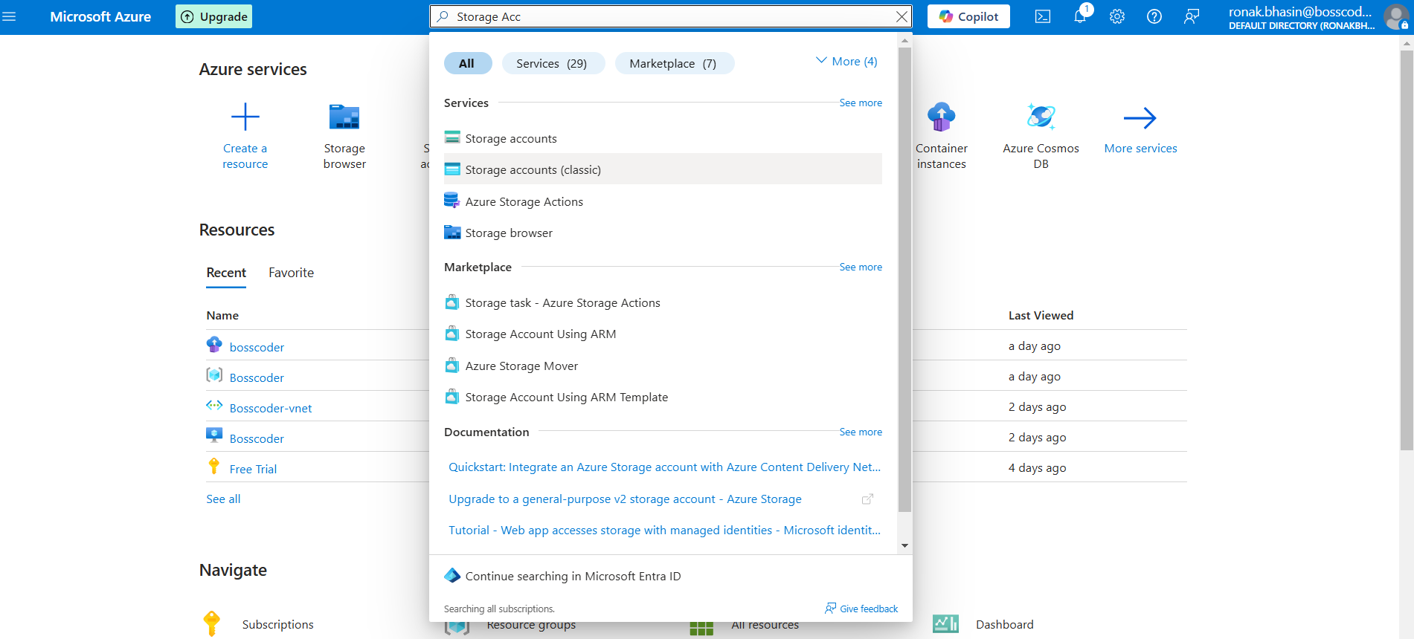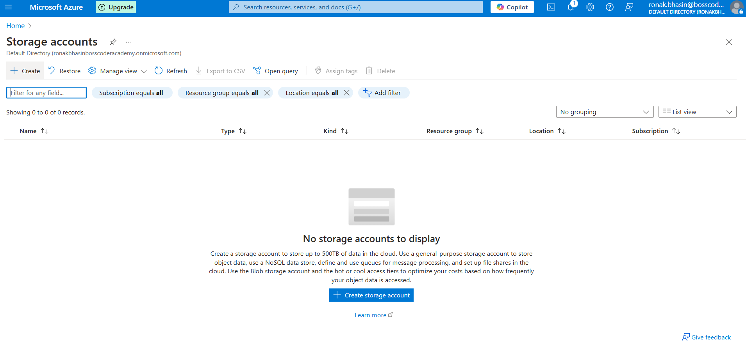
Step 2: Enter the details.
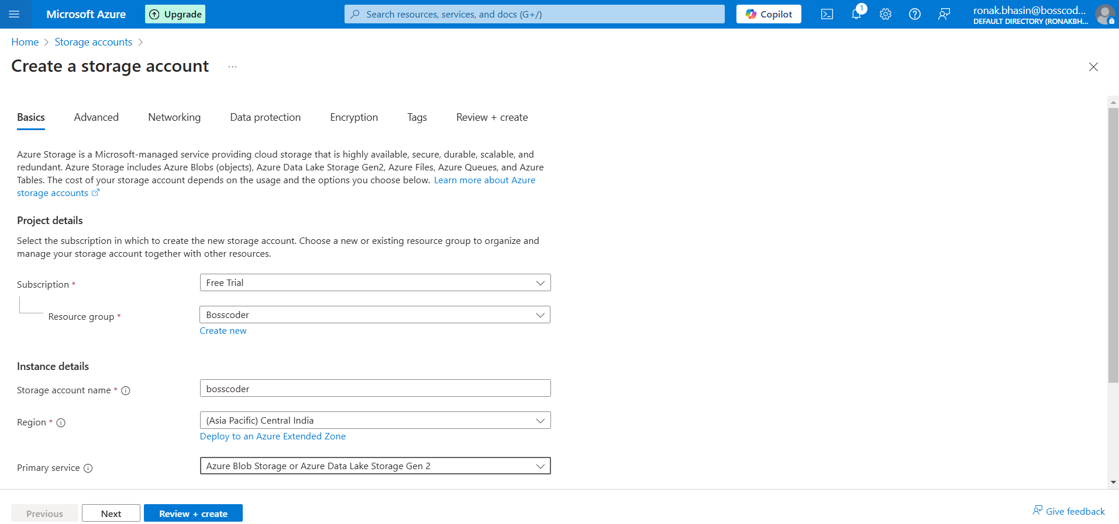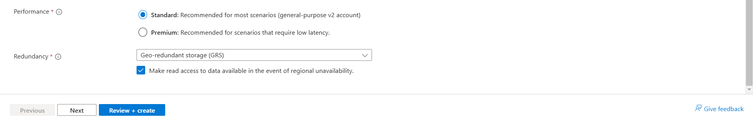
Step 3: Now, go to the Advanced section and select the Access tier from Hot, Cool, Old.
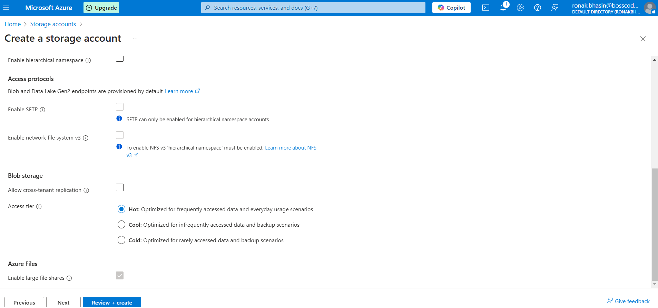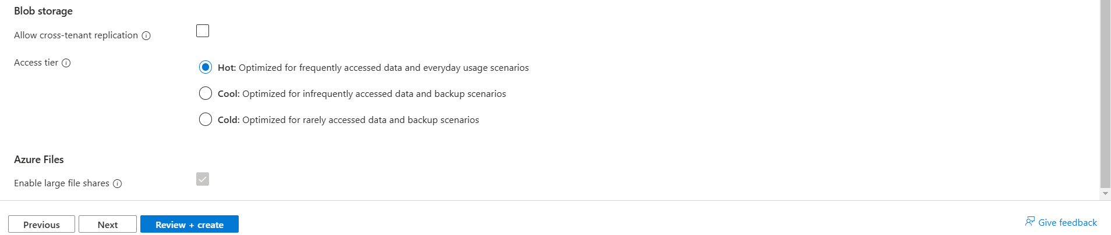
Step 4: Go to the Networking section and select Selection of Network.
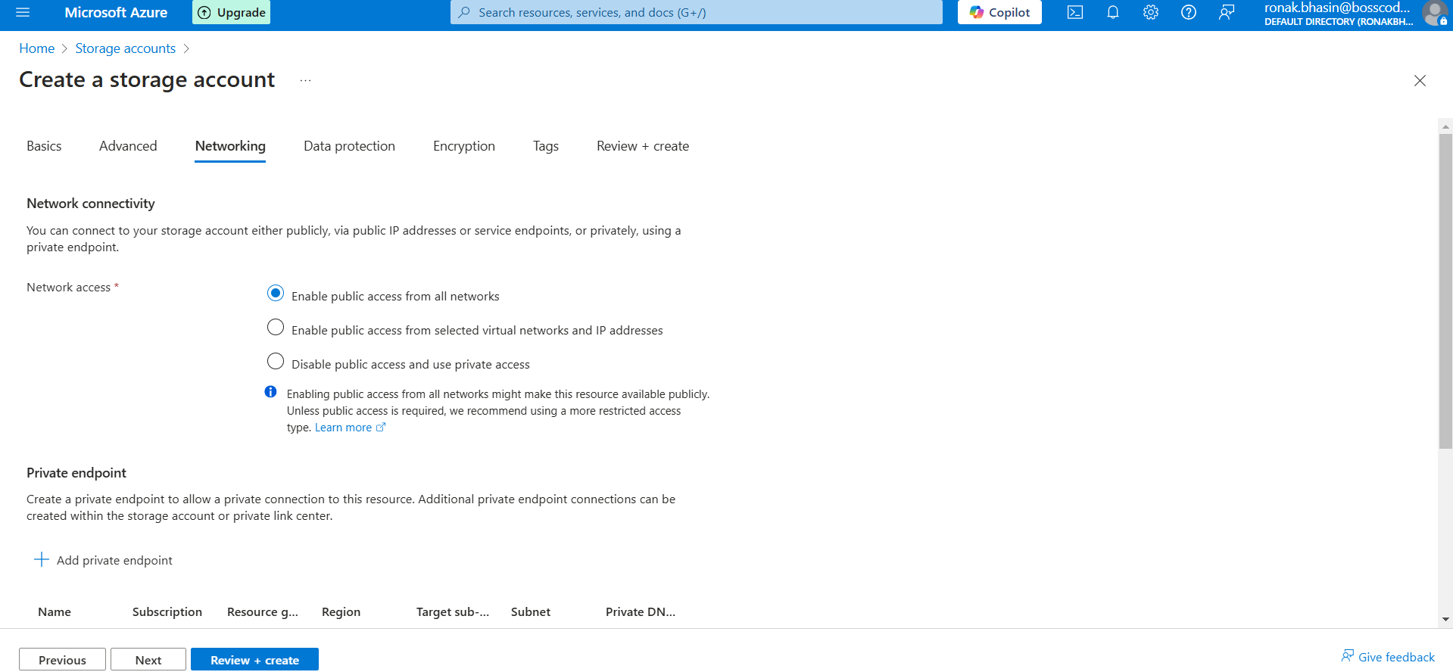
Step 5: Now, go to the Encryption section and select the type of Encryption.
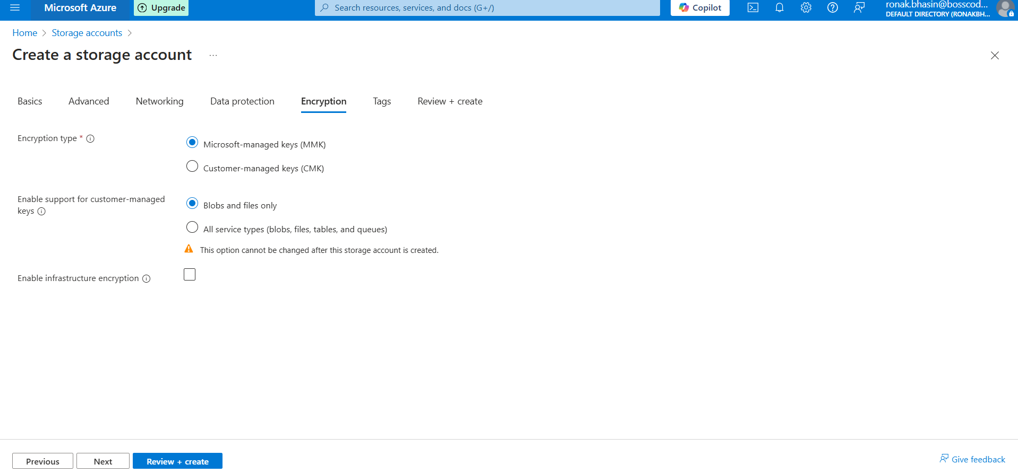
Step 6: Now, go to Review+Create and create the Storage Account.
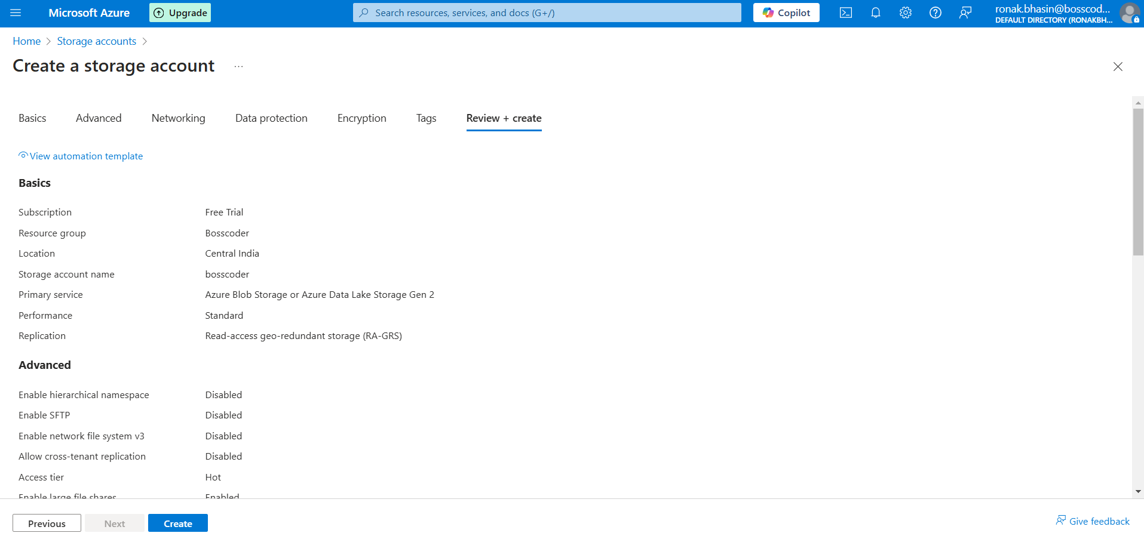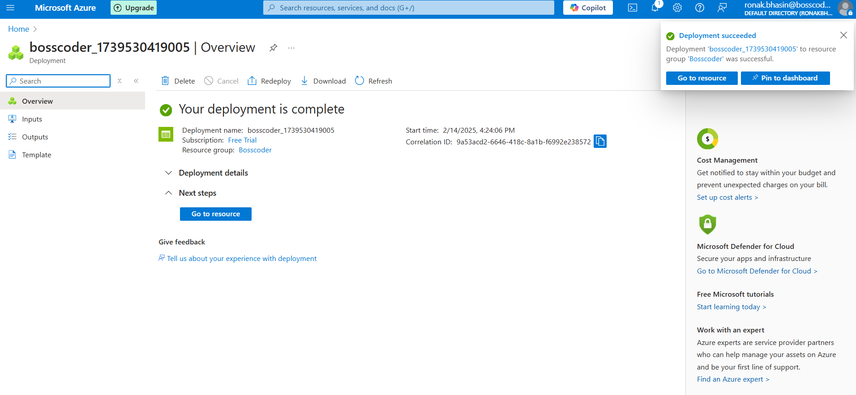
Step 7: You can check the Storage Account and check your Storage Account.
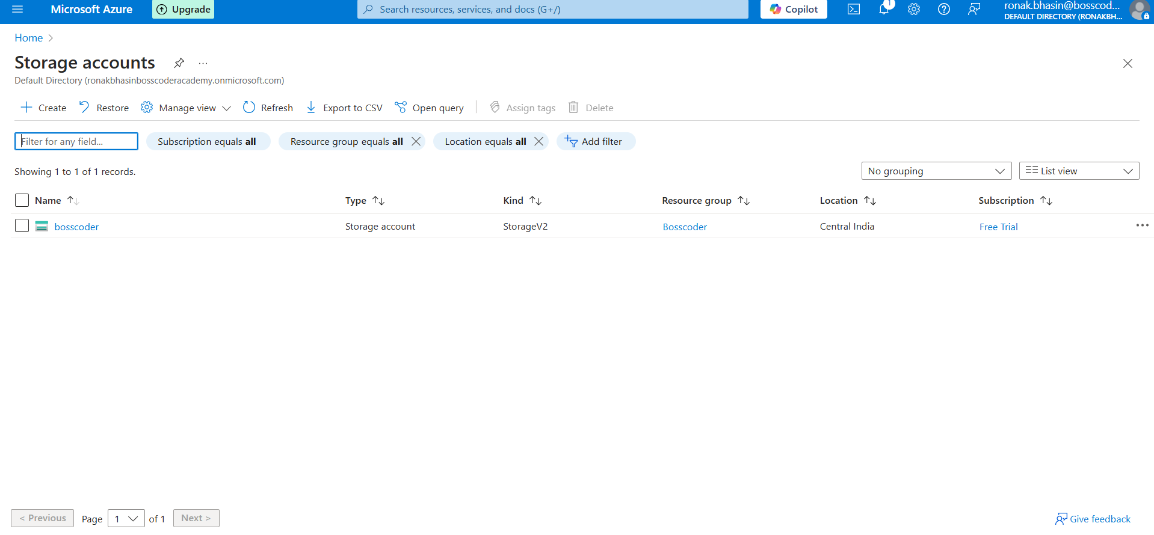
Upload Data Based on Storage Type:
A. Uploading Files to Blob Storage (Unstructured Data):
Step 1: Open the Storage Account from the Azure Portal.
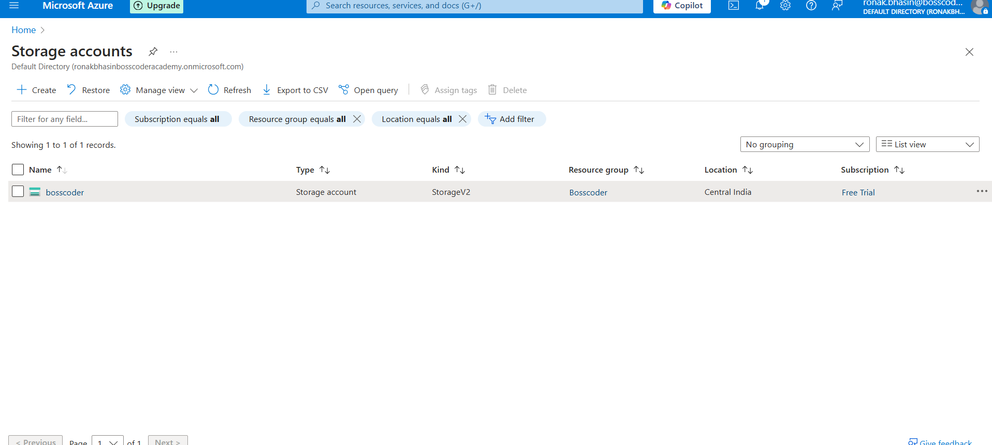
Step 2: On the left menu, go to Containers → Click + Container.
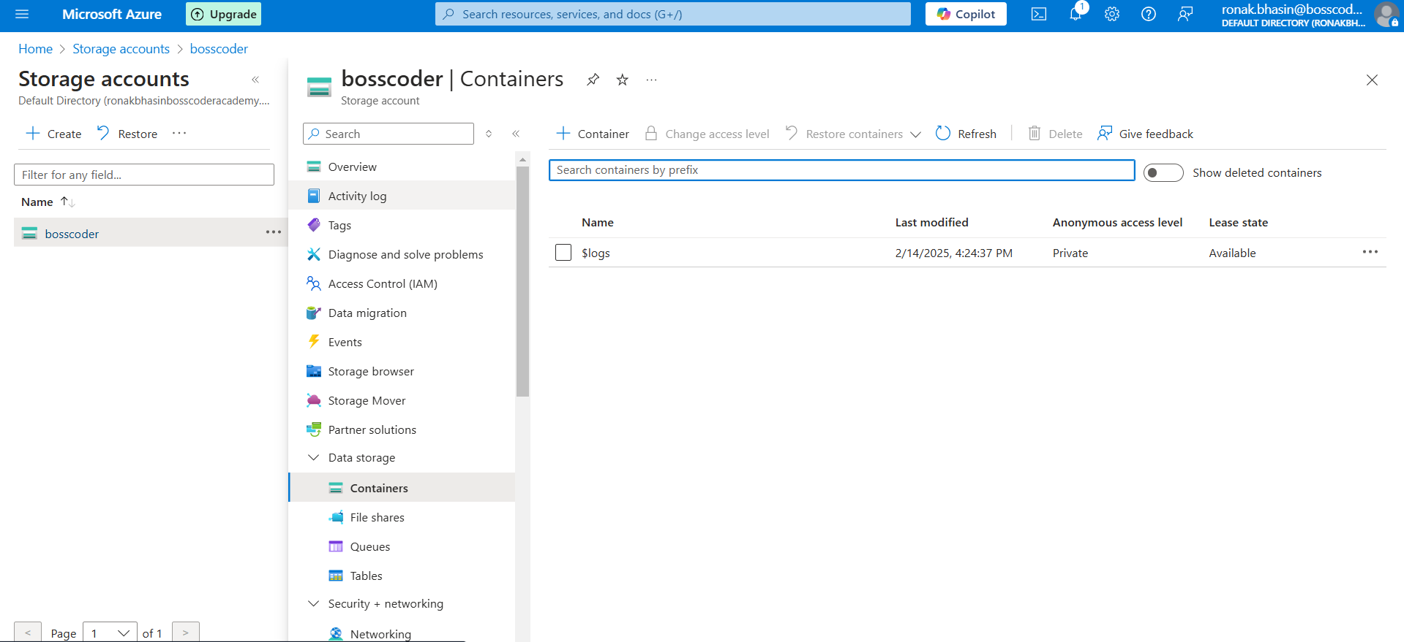
Step 3: ChooseEnter a Container Name (e.g., mycontainer).
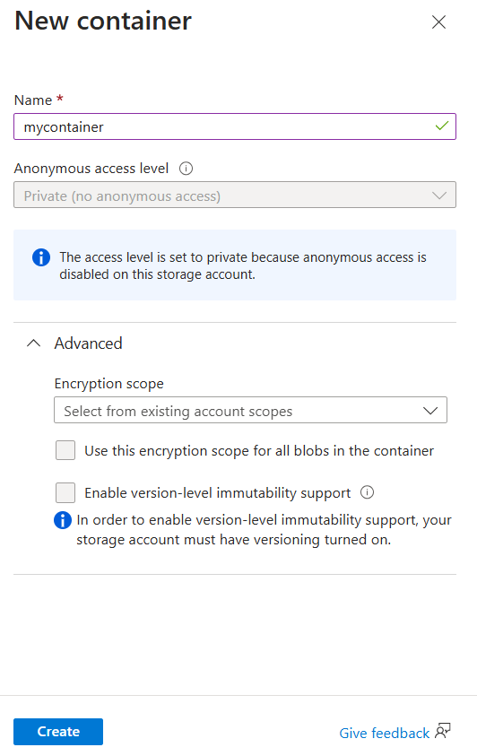
Step 4: Public access level (Private or Public).
Step 5: Click Create.
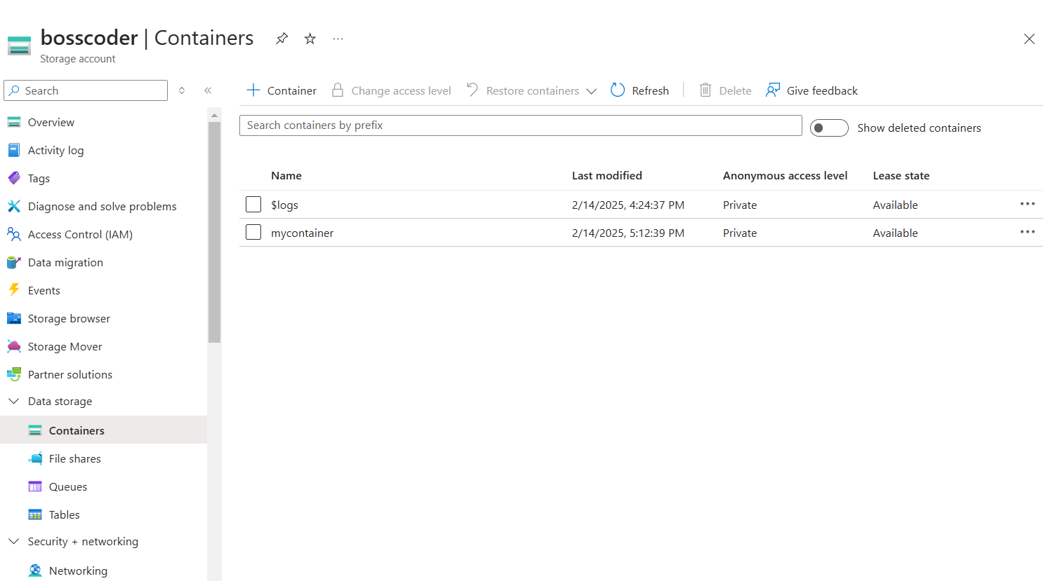
Step 6: Open the newly created container and click Upload.
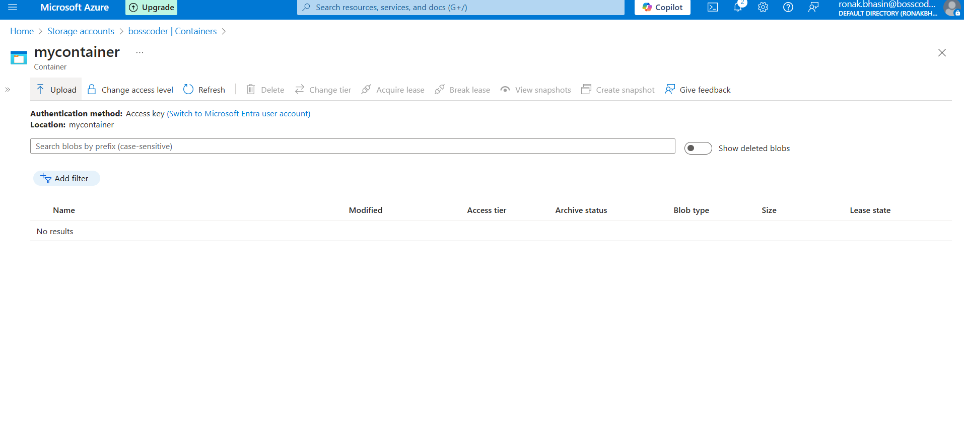
Step 7: Click Browse, select a file from your computer, and click Upload.
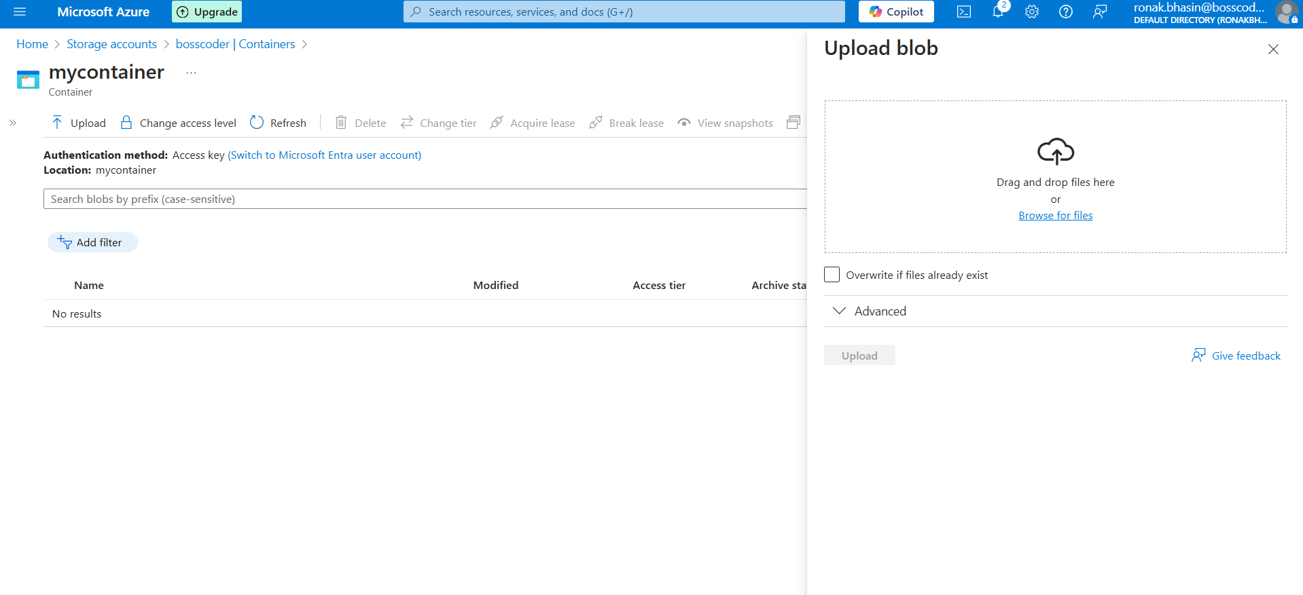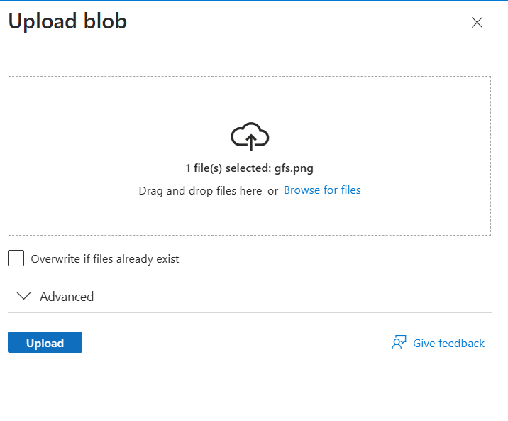
Step 8: Your file is now stored as a Blob in Azure.
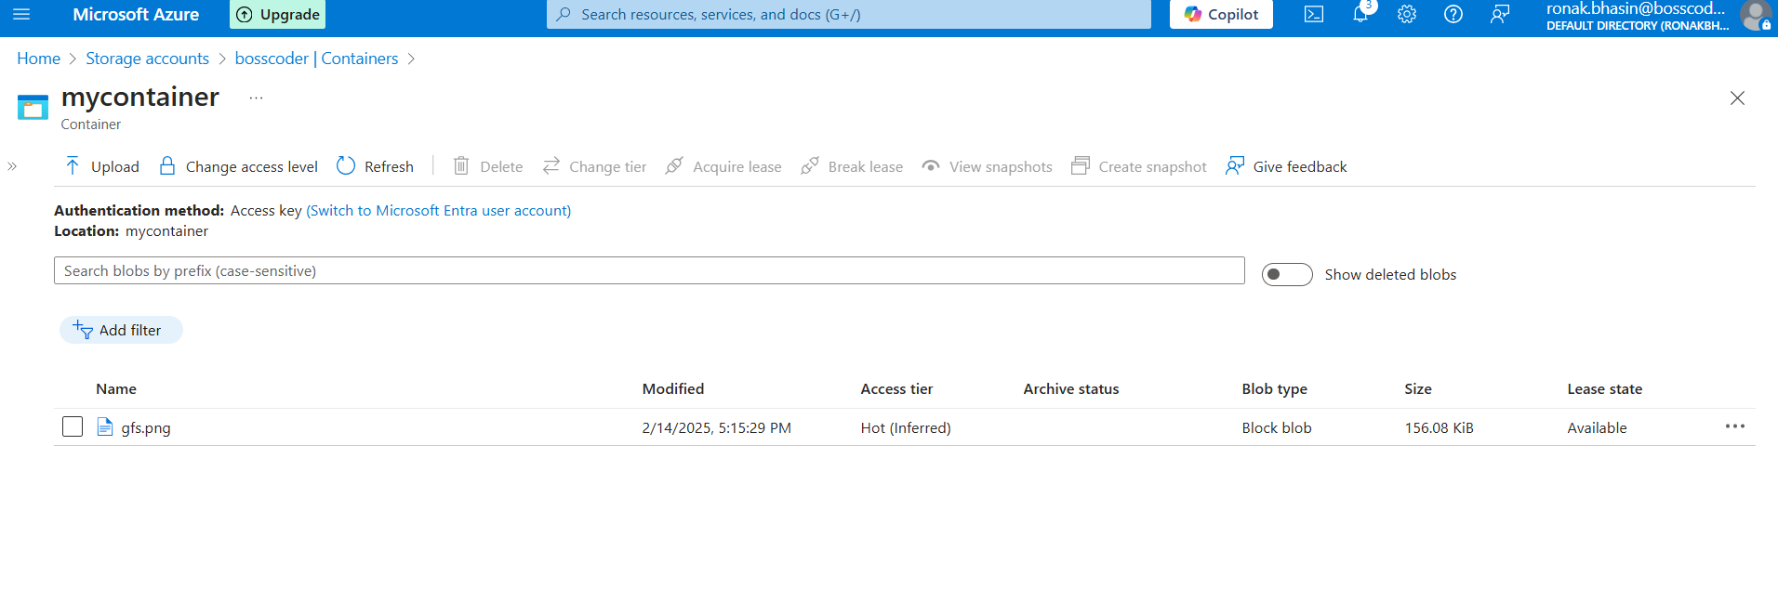
B. Uploading Files to Azure File Storage (SMB/NFS File Share)
Step 1: Open the Storage Account from the Azure Portal.
Step 2: On the left menu, go to File Shares → Click + File Share.
Step 3: Enter a File Share Name and set a Quota (optional).
Step 4: Click Create.
Step 5: Open the newly created file share and click Upload.
Step 6: Select files from your local machine and click Upload.
Step 7: Your files are now stored in Azure File Storage.
C. Storing Structured Data in Azure Table Storage (NoSQL Key-Value Store)
Step 1: Open the Storage Account from the Azure Portal.
Step 2: On the left menu, go to Tables → Click + Table.
Step 3: Enter a Table Name (e.g., CustomerData).
Step 4: Click OK.
Step 5: Now, you can add entities (key-value pairs) manually or use Azure SDKs to insert/query data.
D. Using Azure Queue Storage (For Messaging & Background Jobs)
Step 1: Open the Storage Account from the Azure Portal.
Step 2: On the left menu, go to Queues → Click + Queue.
Step 3: Enter a Queue Name (e.g., taskqueue).
Step 4: Click OK.
Step 5: You can now add, retrieve, or delete messages from the queue.
Monitoring & Managing Storage:
Azure provides monitoring tools to track storage usage and activity.
Enabling Storage Metrics:
Step 1: Open your Storage Account.
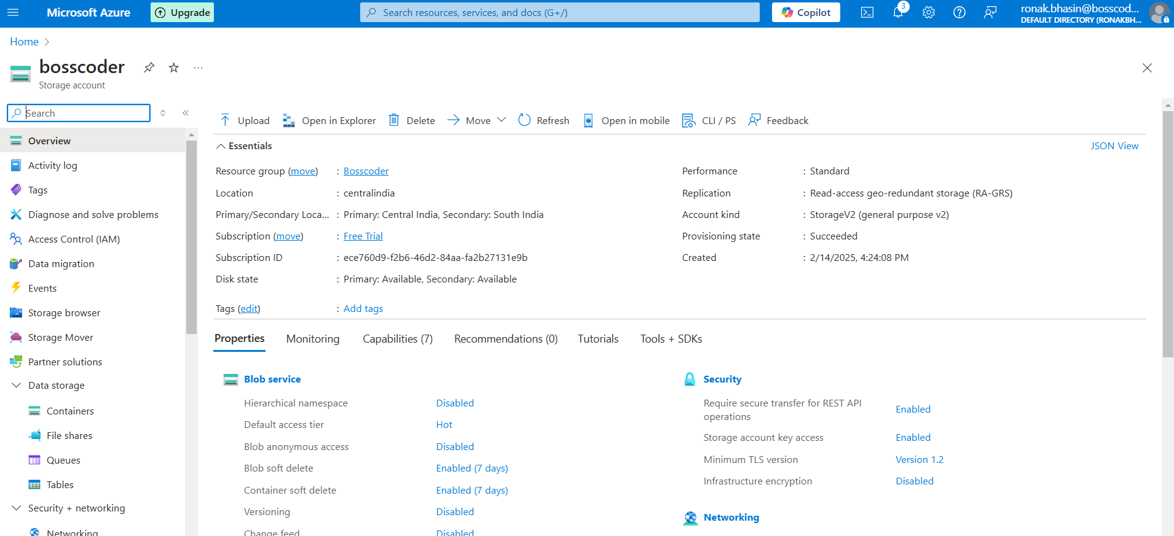
Step 2: Click on Monitoring → Metrics.
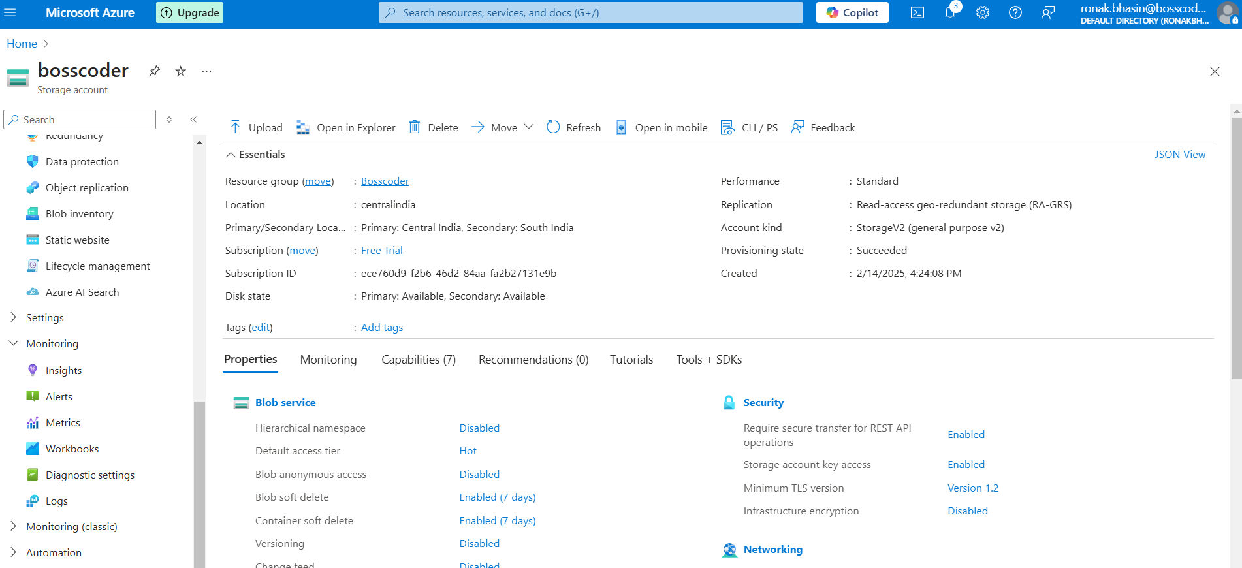
Step 3: Select a metric type (e.g., Used Capacity, Transactions, Ingress/Egress).
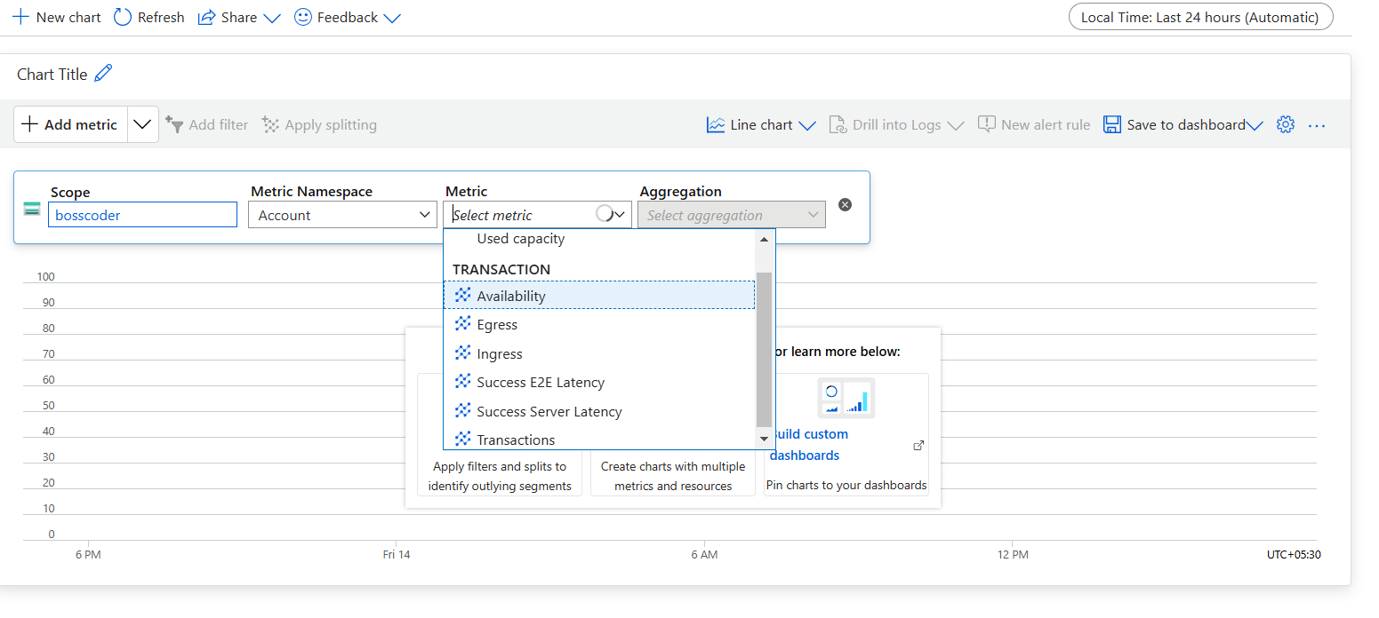
Step 4: View real-time graphs and set alerts if needed.
Networking in Azure:
Azure Networking is the foundation for cloud-based connectivity. It enables communication between virtual machines, applications, and external networks, ensuring security and performance.
Key Features of Azure Networking:
- Scalability: Supports small to large-scale network architectures.
- Security: Network Security Groups, Firewalls, and DDoS protection.
- Hybrid Connectivity: VPNs, ExpressRoute, and Virtual WAN for hybrid cloud setups.
- Performance Optimization: Load Balancers, Content Delivery Networks (CDN), and Traffic Management.
Azure Virtual Network (VNet):
Azure Virtual Network (VNet) is a fundamental networking service in Azure that enables secure communication between Azure resources like Virtual Machines (VMs), databases, and services.It is similar to a traditional on-premises network but operates in the cloud, offering isolation, scalability, and flexibility.
Key Features of VNet:
1. Isolation & Security - Each VNet is logically isolated from others, ensuring data privacy.2. Subnetting → Divide VNet into subnets to organize resources and control traffic.3. Custom IP Addressing → Use private/public IPs and define custom IP ranges.4. Network Security Groups (NSGs) → Control inbound and outbound traffic with firewall rules.5. Internet & On-Premises Connectivity → Connect VMs to the internet or link with on-premises networks via VPN Gateway or ExpressRoute.6. VNet Peering → Connect multiple VNets for resource sharing and communication.7. Integration with Azure Services → Works with Load Balancers, Firewalls, DNS, and Application Gateways for advanced networking.
Use Cases of VNet:
- Connecting Virtual Machines - Enables VMs in the same or different subnets to communicate securely.
- Hybrid Cloud Networking - Connect on-premises infrastructure with Azure using VPN Gateway or ExpressRoute.
- Internet Access & Security - Configure Public IPs, NAT Gateway, and firewalls for controlled internet access.
- Traffic Management & Load Balancing - Distribute network traffic efficiently using Azure Load Balancer.
- High Availability & Disaster Recovery - Use Availability Zones and multiple VNets to ensure uptime and failover support.
Components of VNet:
- Subnets - Divide a VNet into logical sections for better control
- IP Addressing - Assign private/public IPs to Azure resources.
- NSGs (Network Security Groups) - Define firewall rules for traffic filtering.
- Peering - Connect different VNets for communication.
- VPN Gateway - Establish secure connections with on-premises networks.
- Azure Load Balancer - Distribute traffic across multiple VMs.
Steps to Create a VNet:
Step 1: Go to Azure Portal and search for Virtual Network and then click on Create option.
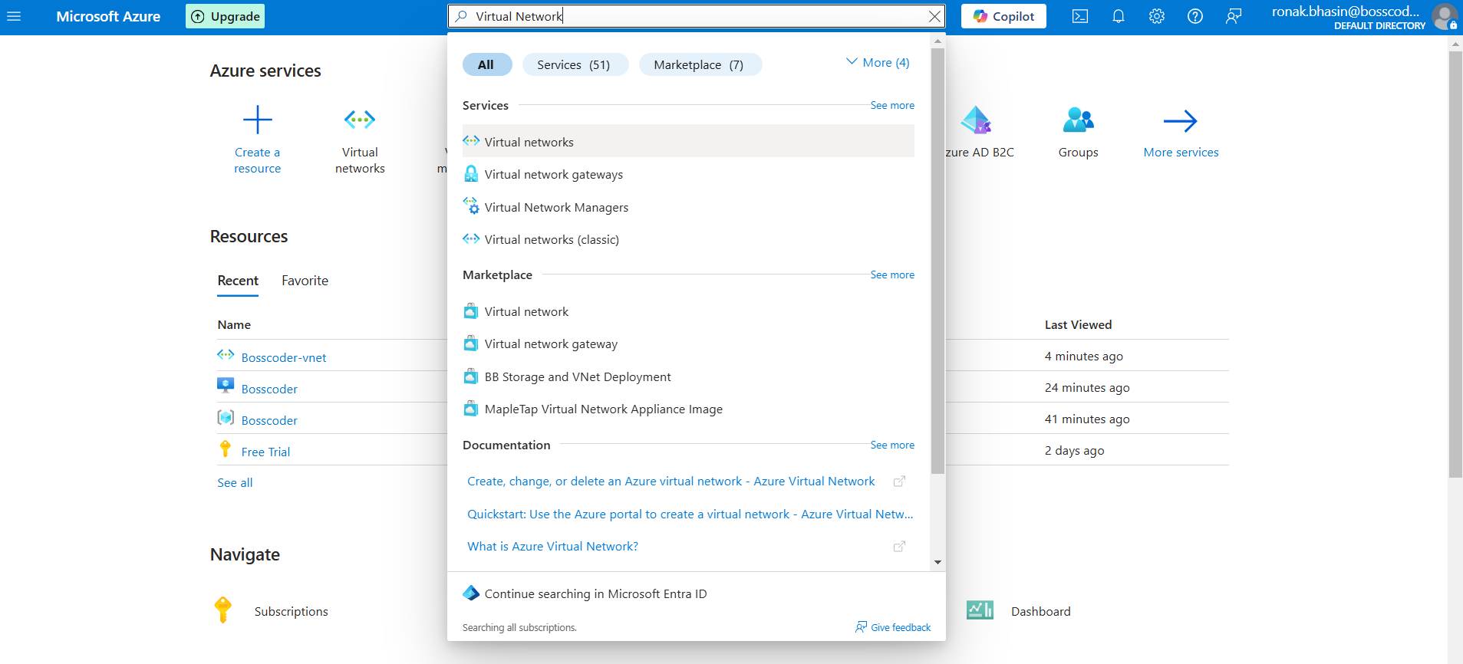
Step 2: Now, name the VNet and select the Region.
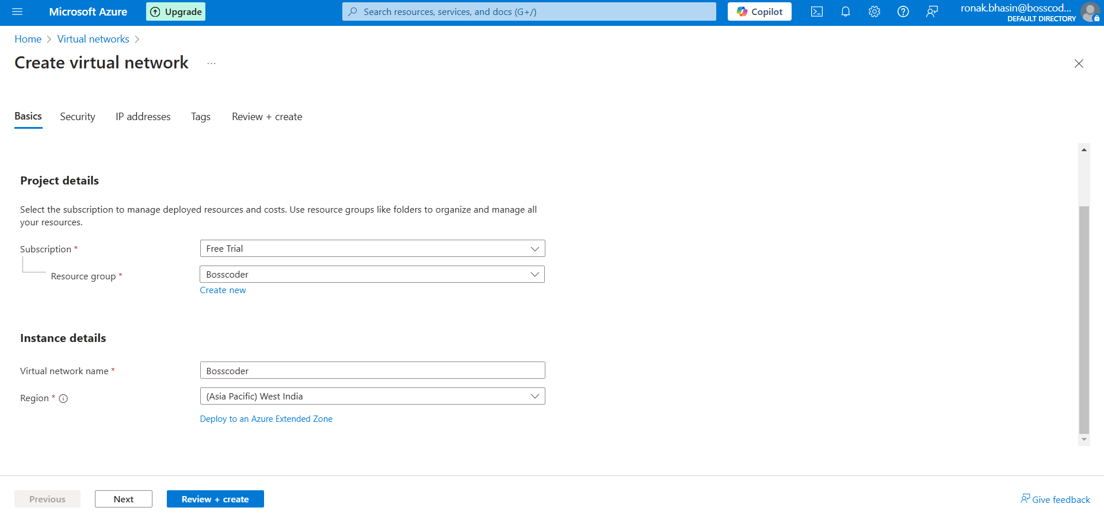
Step 3: Then, select the Security.
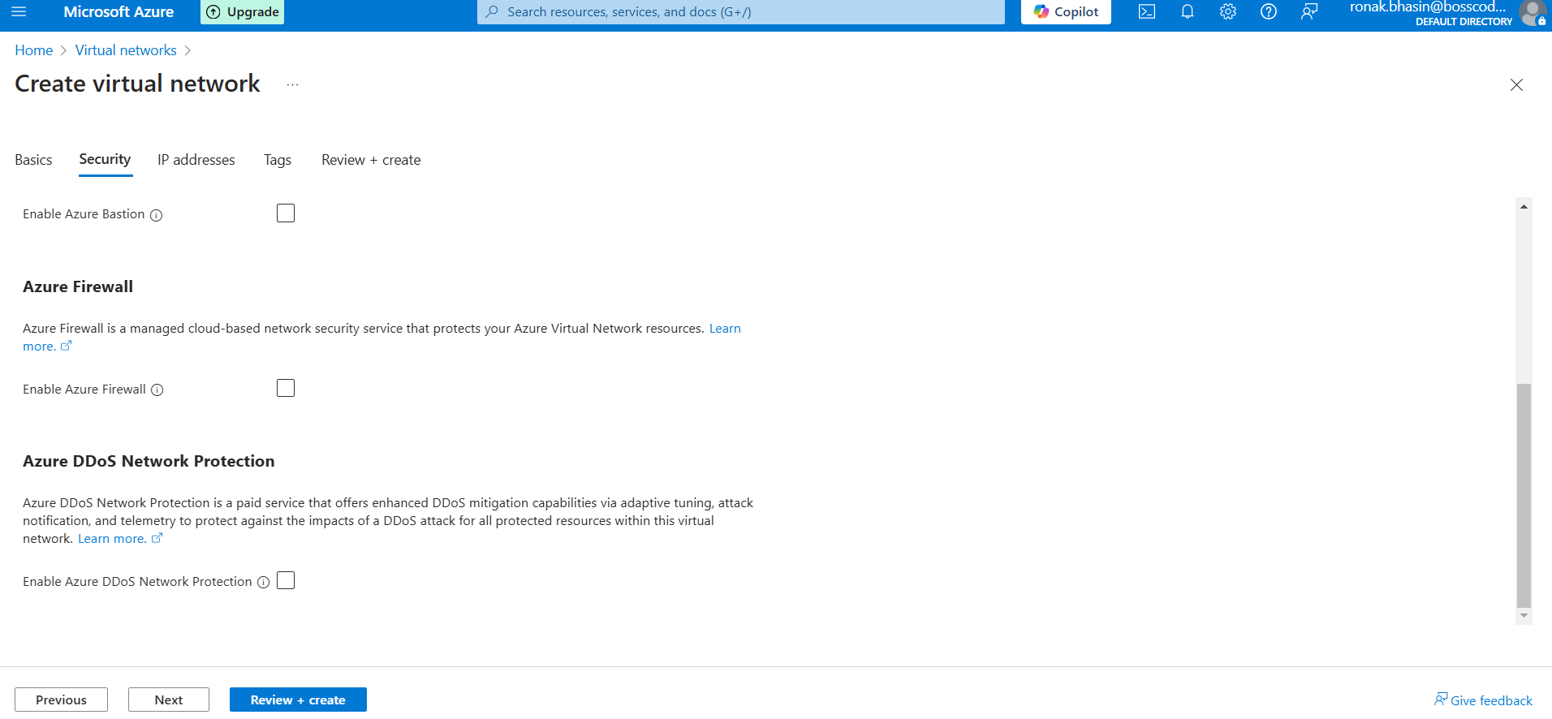
Step 4: Now, go through the IP addresses.
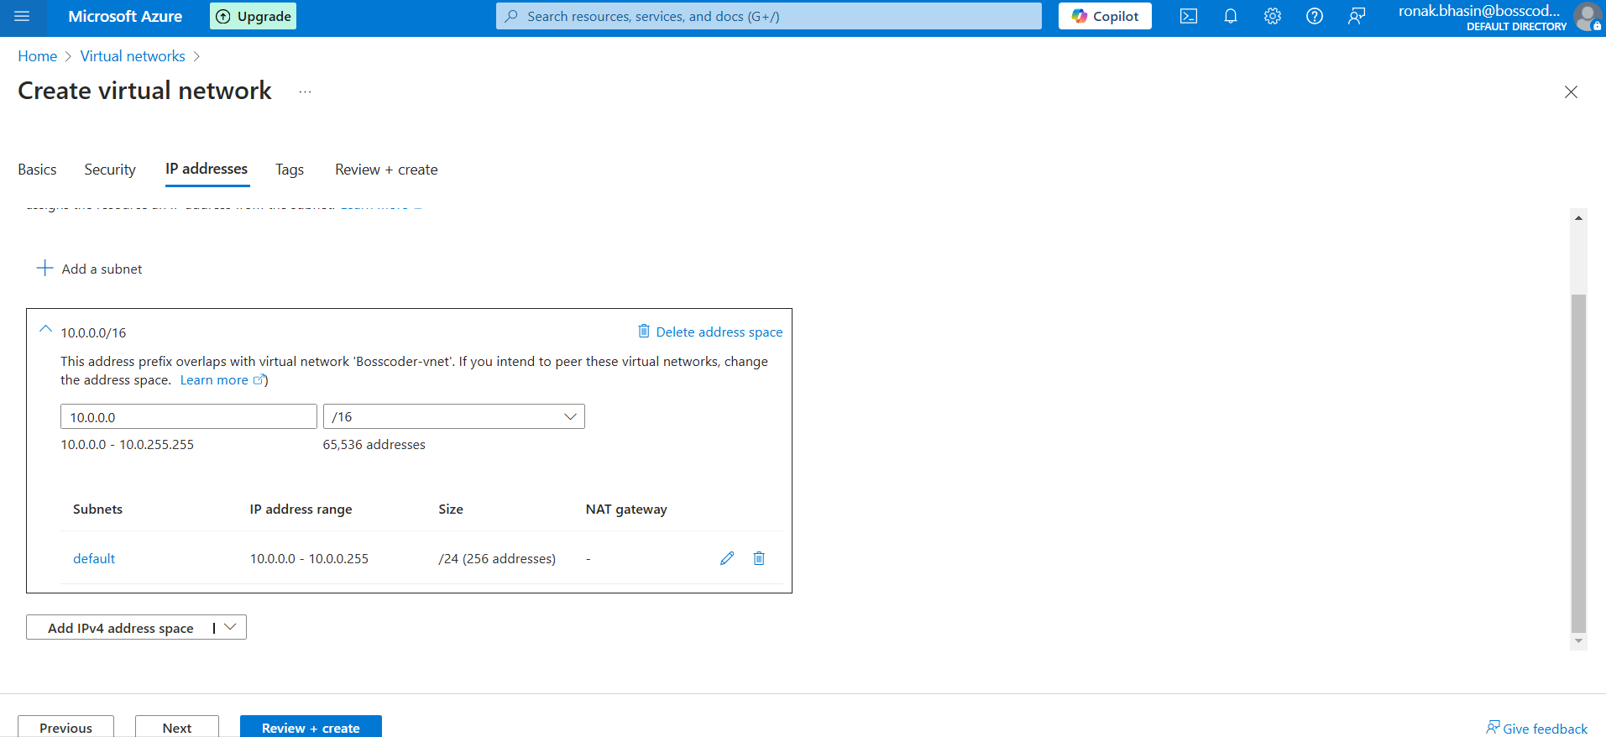
Step 5: Now, click on Create to create the VNet.
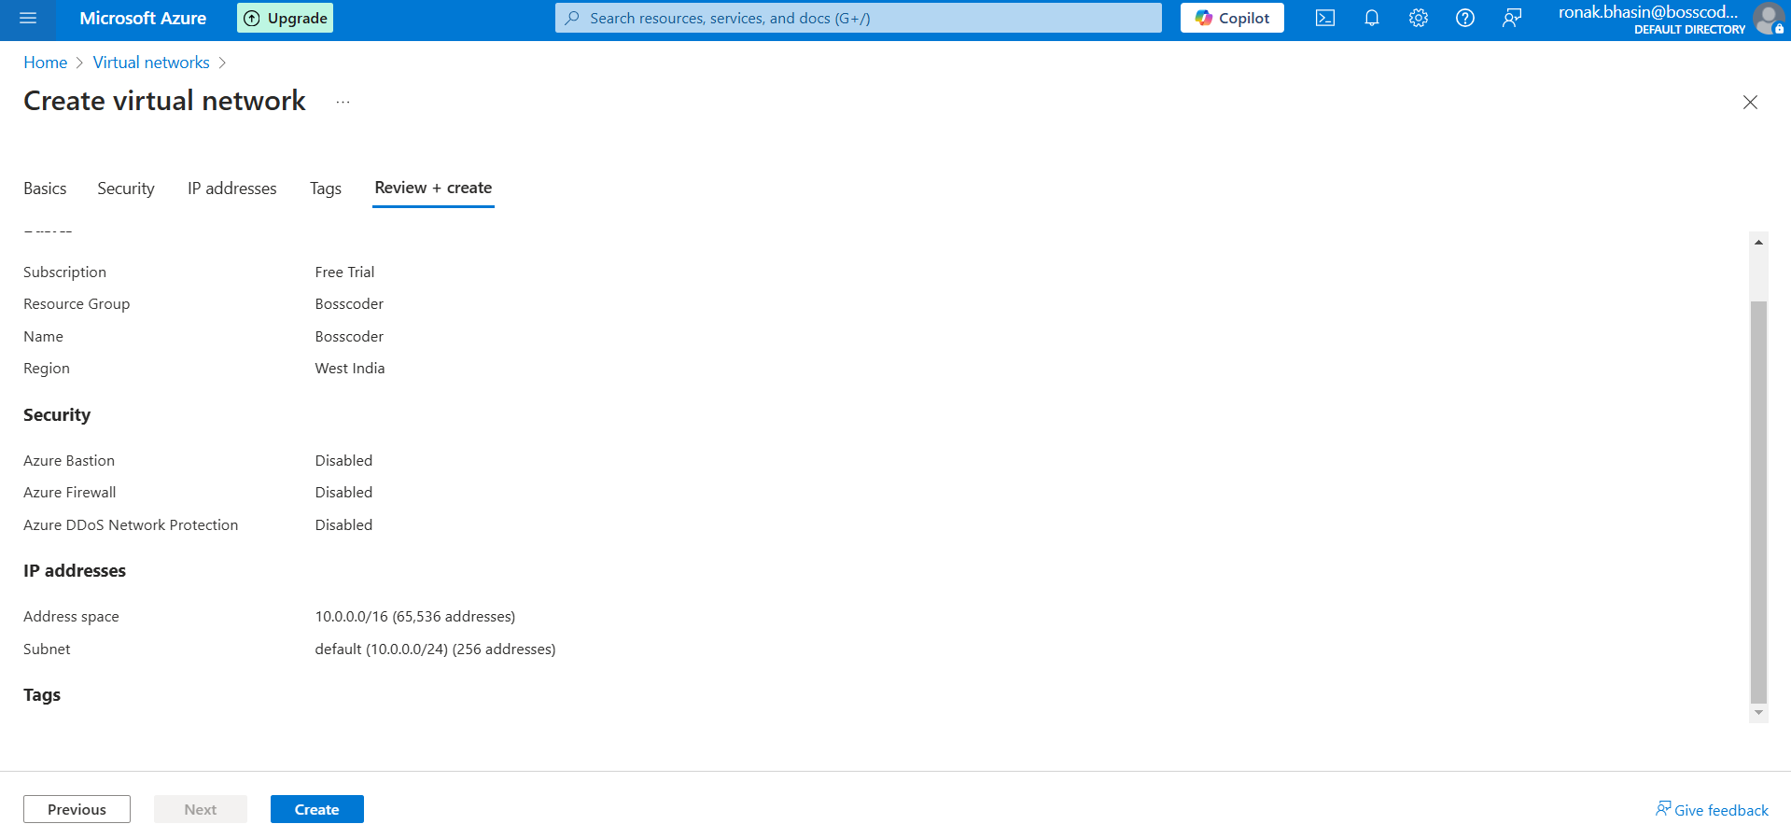
Step 6: Now, you can go through your VNet from here.
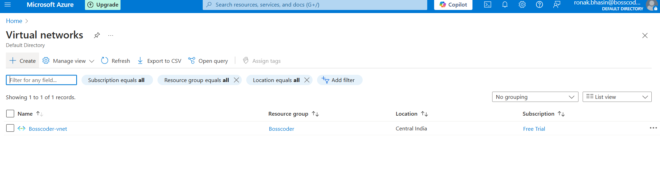
Azure Database and Analytics:
Azure offers a wide range of database solutions for different workloads.
Types of Databases in Azure:
1. Relational Databases (SQL-based databases)
- Azure SQL Database – Managed SQL database service with built-in intelligence, scalability, and security.
- Azure Database for MySQL – Fully managed MySQL database with high availability and automated backups.
- Azure Database for PostgreSQL – Scalable PostgreSQL database with security and performance optimization.
2. NoSQL Databases (Non-relational databases)
- Azure Cosmos DB – Multi-model, globally distributed NoSQL database supporting document, key-value, column-family, and graph models.
3. Big Data & Analytics Databases
- Azure Data Lake – Scalable storage service for big data analytics and processing.
- Azure Synapse Analytics – Enterprise analytics service that integrates big data and data warehousing.
- Azure Databricks – Apache Spark-based analytics service for AI, big data, and machine learning.
Benefits of Azure Databases:
- Scalability – Automatically scales up/down based on workload demand, ensuring cost-effectiveness and performance.
- Security – Advanced security features like encryption, access controls, and compliance with industry standards.
- High Availability – Built-in redundancy, failover capabilities, and geo-replication for continuous uptime.
- Managed Services – Fully managed solutions with automated updates, backups, and monitoring to reduce operational overhead.
1. Azure SQL Database (PaaS SQL Solution):
- A fully managed Platform-as-a-Service (PaaS) relational database.
- Provides built-in high availability, automated backups, and scalability.
- Eliminates the need for database maintenance, patching, and updates.
Features:
Supports T-SQL (Transact-SQL) – Standard query language for database management.Automatic Scaling – Dynamically scales resources based on workload demand.AI-powered Performance Tuning – Uses machine learning to optimize queries and indexing.
Security Features:
- Transparent Data Encryption (TDE) – Encrypts data at rest.
- Always Encrypted – Protects sensitive data using client-side encryption.
Deployment Options:
- Serverless – Auto-pauses and resumes based on usage to reduce costs.
- Hyperscale – Supports high-performance workloads with fast scaling and large data storage.
Use Cases:
- Web Applications – Scalable backend for websites and SaaS applications.
- Business Applications – ERP, CRM, and other enterprise systems.
- Analytics Workloads – Data warehousing, reporting, and business intelligence.
2. Azure Cosmos DB (NoSQL Solution):
- A fully managed NoSQL database designed for globally distributed applications.
- Ensures low latency, high availability, and scalability for modern applications.
- Provides multi-region replication with seamless failover.
Features:
Multi-Model Support – Supports different data models:
- Key-Value
- Document (MongoDB, Gremlin API)
- Graph
- Column-Family
- Table Storage Low Latency & High Availability – 99.999% SLA-backed uptime. Global Distribution – Data is automatically distributed across multiple regions. Auto-Scaling – Adjusts throughput based on demand.
Use Cases:
- IoT Applications – Handles massive real-time data ingestion.
- Social Media Apps – Stores and processes user-generated content at scale.
- Real-Time Analytics – Enables fast insights on large-scale datasets.
- Gaming Platforms – Manages player data, leaderboards, and game state efficiently.
Azure Cosmos DB is an ideal NoSQL solution for businesses needing a high-performance, globally scalable, and low-latency database.
3. Azure Data Lake:
- A highly scalable storage solution designed for big data workloads.
- Stores structured, semi-structured, and unstructured data efficiently.
- Integrates with big data tools like:
  - Apache Spark
  - Azure Databricks
  - Azure Synapse Analytics
4. Azure Synapse Analytics:
- An integrated analytics service for big data processing and data warehousing.
- Formerly known as Azure SQL Data Warehouse.
- Combines SQL-based querying, data integration, and AI-powered analytics.
Features:
SQL-Based Querying – Enables efficient querying of massive datasets.Serverless & Dedicated Pool Options –
- Serverless – Pay-as-you-go, ideal for ad-hoc queries.
- Dedicated Pool – Pre-allocated resources for high-performance workloads.Built-in AI & Machine Learning – Enhances data insights and predictive analytics.
Use Cases:
- Enterprise Reporting – Centralized data storage for business intelligence.
- Business Intelligence (BI) – Supports dashboards and real-time analytics.
- Predictive Analytics – Leverages AI/ML to forecast trends and patterns.
Azure Data Lake and Synapse Analytics work together to provide a powerful, scalable, and AI-driven solution for big data storage, processing, and analytics.
5. Azure Databricks (For Big Data & AI):
- An Apache Spark-based big data analytics platform.
- Optimized for Azure, built for AI, machine learning (ML), and large-scale data processing.
- Provides a collaborative workspace for data engineers, analysts, and data scientists.
Features:
Auto-Scaling Clusters – Automatically adjusts resources based on workload.Interactive Notebooks – Supports real-time collaboration and visualization.Multi-Language Support – Works with Python, Scala, SQL, and R.Seamless Integration with:
- Azure Data Lake – For scalable data storage.
- Azure Synapse Analytics – For data warehousing and analytics.
- Power BI – For business intelligence and reporting.
Use Cases:
- AI/ML Workflows – Builds and trains machine learning models at scale.
- Real-Time Streaming – Processes live data streams for quick insights.
- Data Transformation – Cleans, processes, and prepares data for analytics.
Azure Databricks is a powerful, scalable, and AI-driven platform, making it ideal for big data analytics, real-time processing, and machine learning applications.
Deploying Azure SQL Database & Querying Data:
Step 1: Go to Azure Portal.
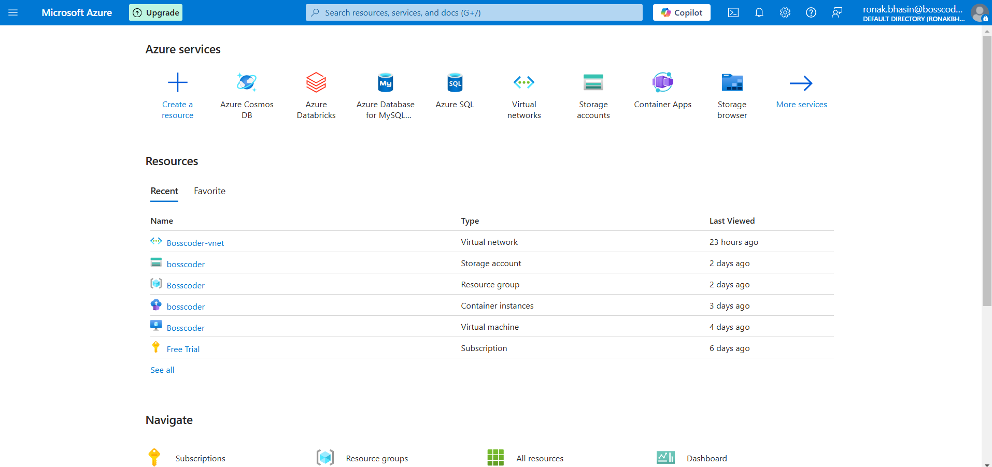
Step 2: Search for Azure SQL Database and select it.
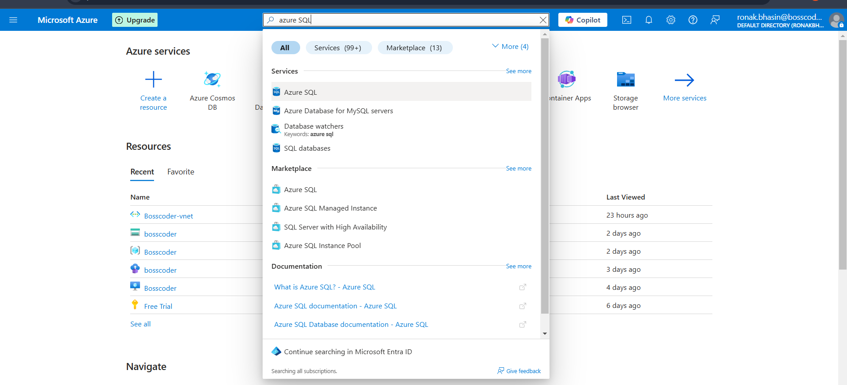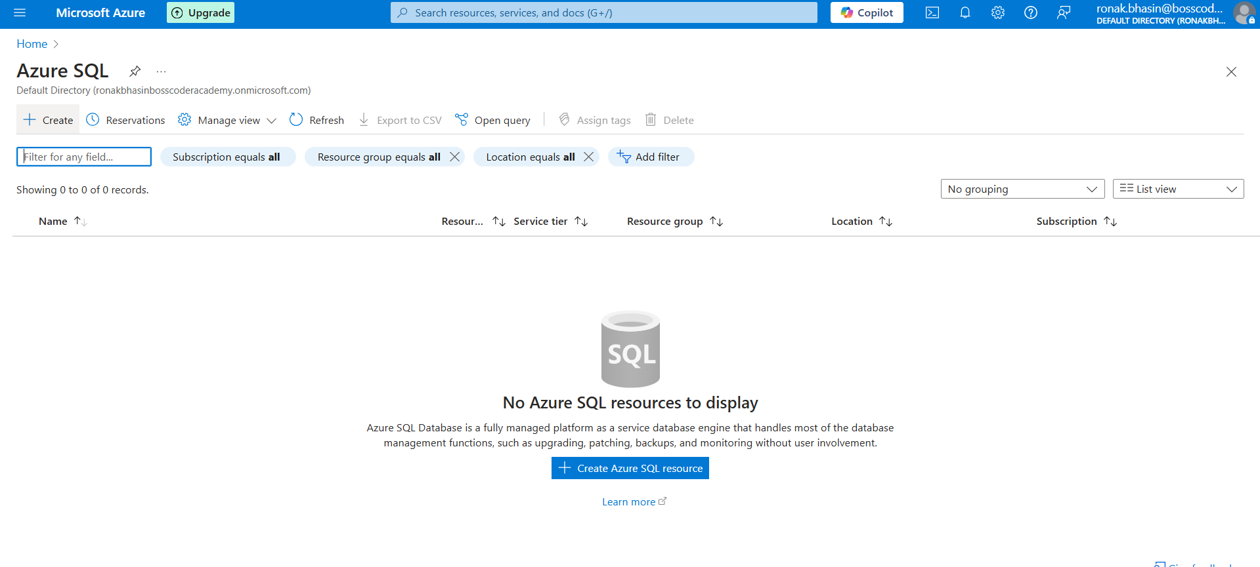
Step 3: Click Create to start the deployment.
Step 4: Choose SQL Deployment option and Resource Group (create a new one if needed).
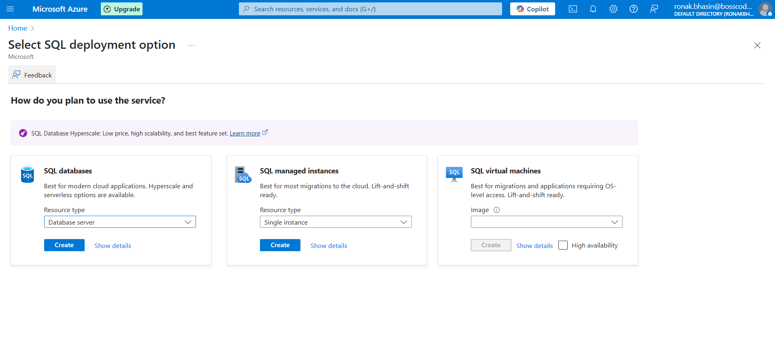
Step 5: Enter Database Name (e.g., myAzureDB) and also Set Admin name.
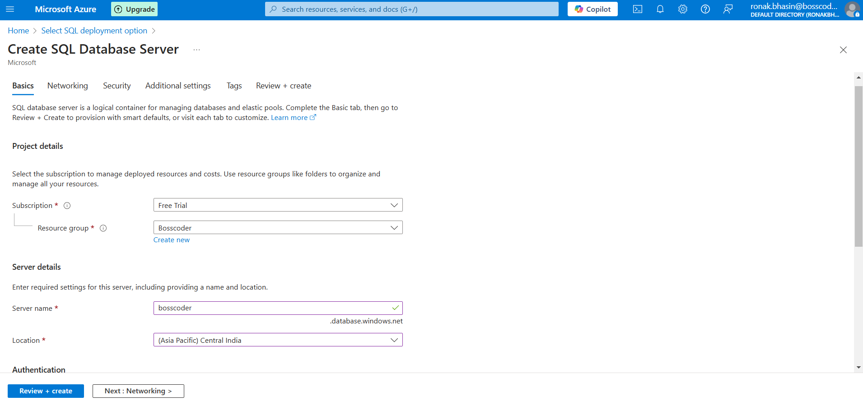
Step 6: Then, set Settings of Networking, Security, Tags as per you.
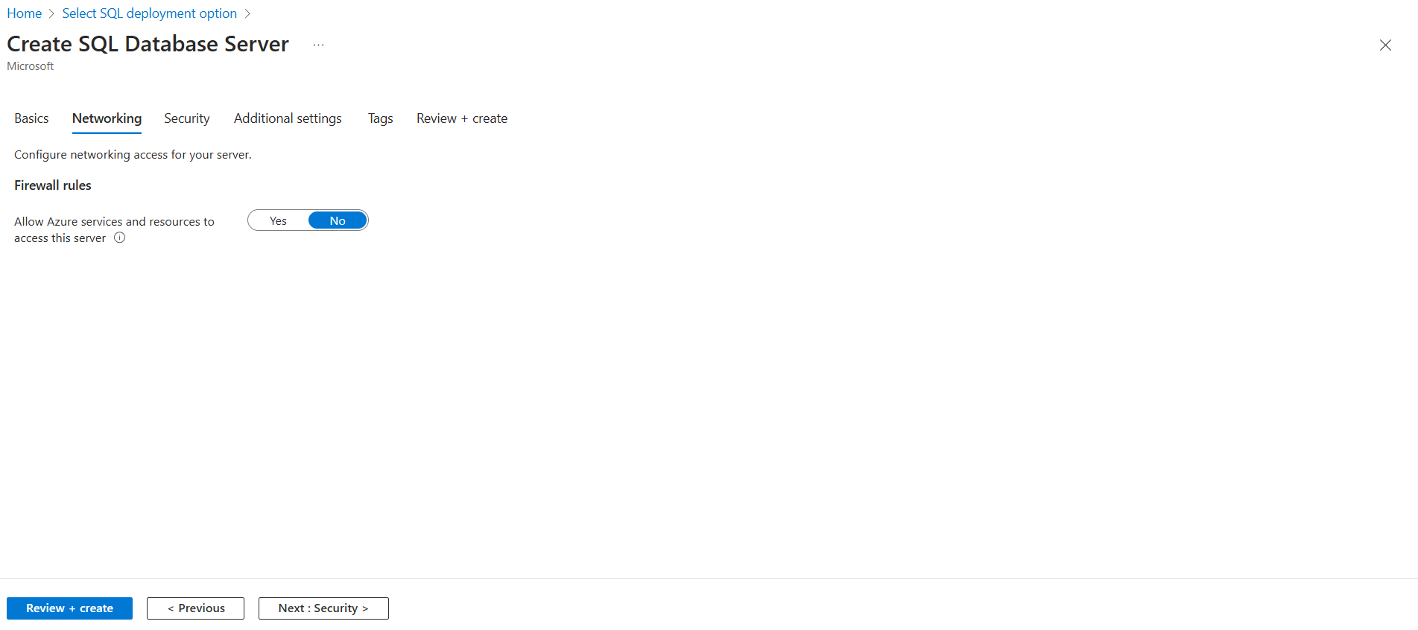
Step 7: Click Review + Create, then click Create to deploy the database.
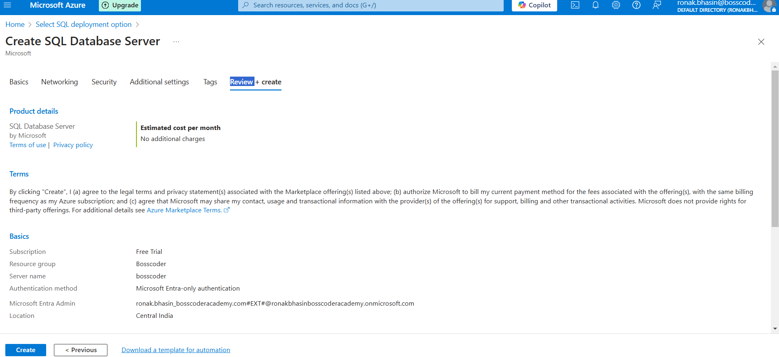
Step 8: Wait for deployment to complete and go to the resource that was deployed.
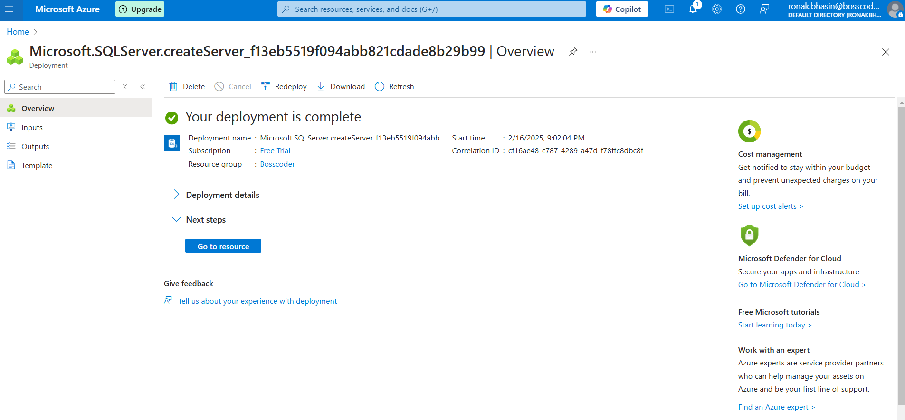
Step 9: On the left side bar, go to SQL Databases (Create one if not created) and then select the Query editor and then sign in using administrator login and password.
